|  |  |
| --- | --- |
| **PRACTICAL ASSESSMENT** | **Uncontrolled when printed**  **16/12/2014**  **FM02_21b** |

|  |  |  |  |  |  |  |  |  |  |  |
| --- | --- | --- | --- | --- | --- | --- | --- | --- | --- | --- |
| **Student Name:** | | | **Angelo Palazzolo** | | | **Student Number:** | | | **3150704699** | |
| **Unit Code/s & Name/s:** | | | ICAWEB505A: Develop Complex web page layouts  ICAWEB506A: Develop complex cascading stylesheets | | | | | | | |
| **Assessment Description:** | | | P1 | | | | | | | |
| **Assessment Due Date:** | | |  | | **Assessment Received Date:** | | | | |  |
| **Student Declaration:** I declare that this assessment is my own work. Any ideas and comments made by other people have been acknowledged as references. I understand that if this statement is found to be false, it will be regarded as misconduct and will be subject to disciplinary action as outlined in the TAFE Queensland Student Rules. I understand that emailing or submitting this assessment electronically confirms my assent to this declaration in lieu of a written signature. | | | | | | | | | | |
| **Student Signature:** | |  | | | | | **Date: / /** | | | |
| **Assessor Feedback:**  **Student provided with feedback** | | | | | | | | | | |
| **Attempt 1 Satisfactory  Not Satisfactory  Date:      /     /** | | | | | | | | | | |
| **Attempt 2 Satisfactory  Not Satisfactory  Date:      /     /** | | | | | | | | | | |
| **Assessor Name:** |  | | | **Assessor Signature:** | | | |  | | |
| **Note to assessor: Please record any adjustment below that has occurred to this assessment e.g. Oral questions were used to support student’s ability to complete tasks identified.** | | | | | | | | | | |
|  | | | | | | | | | | |
| **Disclaimer:** TAFE Queensland North (TQN) is collecting the information on this form for assessment purposes. Only authorised Departmental officers have access to this information. Your personal information will not be disclosed to any other third party without your consent, unless authorised or required by law, in accordance with the Information Privacy Act 2009. | | | | | | | | | | |

**This section must be completed by the student when the student either posts or hands a completed assessment/assignment to customer service centres. a receipt is only issued for face to face assessments when requested by the student.**

✀ **RECEIPT**

|  |  |  |
| --- | --- | --- |
| STUDENT TO COMPLETE |  | OFFICE USE ONLY |
| Unit of competency code/s:__________________ |  |  |
| Assessment item/No: ______________________ |  | Date received: / / |
| Student’s name: __________________________ |  |  |

|  |  |
| --- | --- |
| **Instructions to Student:** | **Time allowed:** This assessment is to be completed over the semester.  **Materials and equipment to be supplied by the Student:**   * Access to a PC, Web Authoring Tools, web server and hosting.   **General Instructions:**   * You will need access to the AllStyles Design Brief * You have 3 tasks to complete. * You will need to answer **all** questions correctly * Keep a copy of all assessments as you will be required, to submit them as a zipped file to your teacher.   NOTE: If you are not successful on your first attempt, you will be given comments and a further two weeks to rectify the changes.  You will need to re-submit your corrections for remarking. If you are unsuccessful on your second attempt, you will be required to re-enrol in this unit. |
| **Instructions to Assessor:** | Please see Instructions to Student above. |
| **Assessment Context and Description: (if required)** | In order to gain competency in ICAWEB505A: Develop Complex web page layouts, successful completion is required of the following assessments items:   * Practical Assessment |
| **Note to Student:** | An Assessment Matrix is available from your teacher upon request. The matrix shows how the knowledge and skills that you are being asked to demonstrate align to the Elements, Performance Criteria, Critical Aspects, Required Skills and Required Knowledge components of each Unit of Competency. |

For this task you will need to review the client requirements from the design brief. You will need to document the following to be included in your report:

1. identify the main sections of the page for layout
2. create an appropriate file / folder structure for the site
3. develop a naming convention for files

**Project**

For this project you need to develop a client website according to the given design brief. The site is to be laid out, styled and formatted using advanced CSS. (If you would like to use a different design brief, this will need to be discussed with your teacher for approval prior to completing this assessment, you will be required to do additional work.)

You will need to create a new folder called '**complex_webpages**' and save all files in this folder. You should create sub folders as necessary.

## Task 1 - review site requirements

Online Systems Solutions was chosen to develop and produce an effective website which addressed the client’s requirements expressed in the design brief. It is important to note that to this point of time AllStyle Homes had no existing website, and as such the proposed website is being developed following detailed discussions with the clients during which time their needs and expectations were identified and the design brief was developed.

The General Requirements of the client were specific:

* Develop a web presence
* Function as a marketing and sales tool
* Increase company profile, nationally and internationally
* Reduce traditional advertising costs
* Streamline sales
* Means of obtaining feedback from customers, both retail and wholesale

The Functional Requirements, were equally specific

* Site to contain eight (8) pages; these being – Home, About, Designs, Our Processes, FAQ, Testimonials, Contact and Privacy. It is acknowledged additional pages may be required to accommodate and organise relevant information. Briefly, ech page would contain the following information:

|  |  |
| --- | --- |
| Page | Contents |
| Home | Introduction and welcome. |
| About | General information about the business |
| Designs | An overview of the standard house designs available. This page should also include an imagemap type document highlighting each of the areas as detailed in the section titled “Imagemap” |
| Our Process | This page should contain information about the building process. |
| FAQ | Containing details answering common questions asked by clients of the business. |
| Testimonials | A page containing testimonials from previous clients |
| Contact | This page should give all contact details for ‘AllStyle Homes’. |
| Privacy | Should contain a privacy statement |

* Each page should contain the following elements
  + Company Logo – provided to us by the company in both a ‘jpg’ and ‘png’ formats
  + Company Slogan “Your tick of approval is our guarantee”
  + Domain – [www.allstylehomes.com.au](http://www.allstylehomes.com.au)
  + Copyright statement – “© 2012 AllStyle Homes”
* Each page should be presented with the following layout

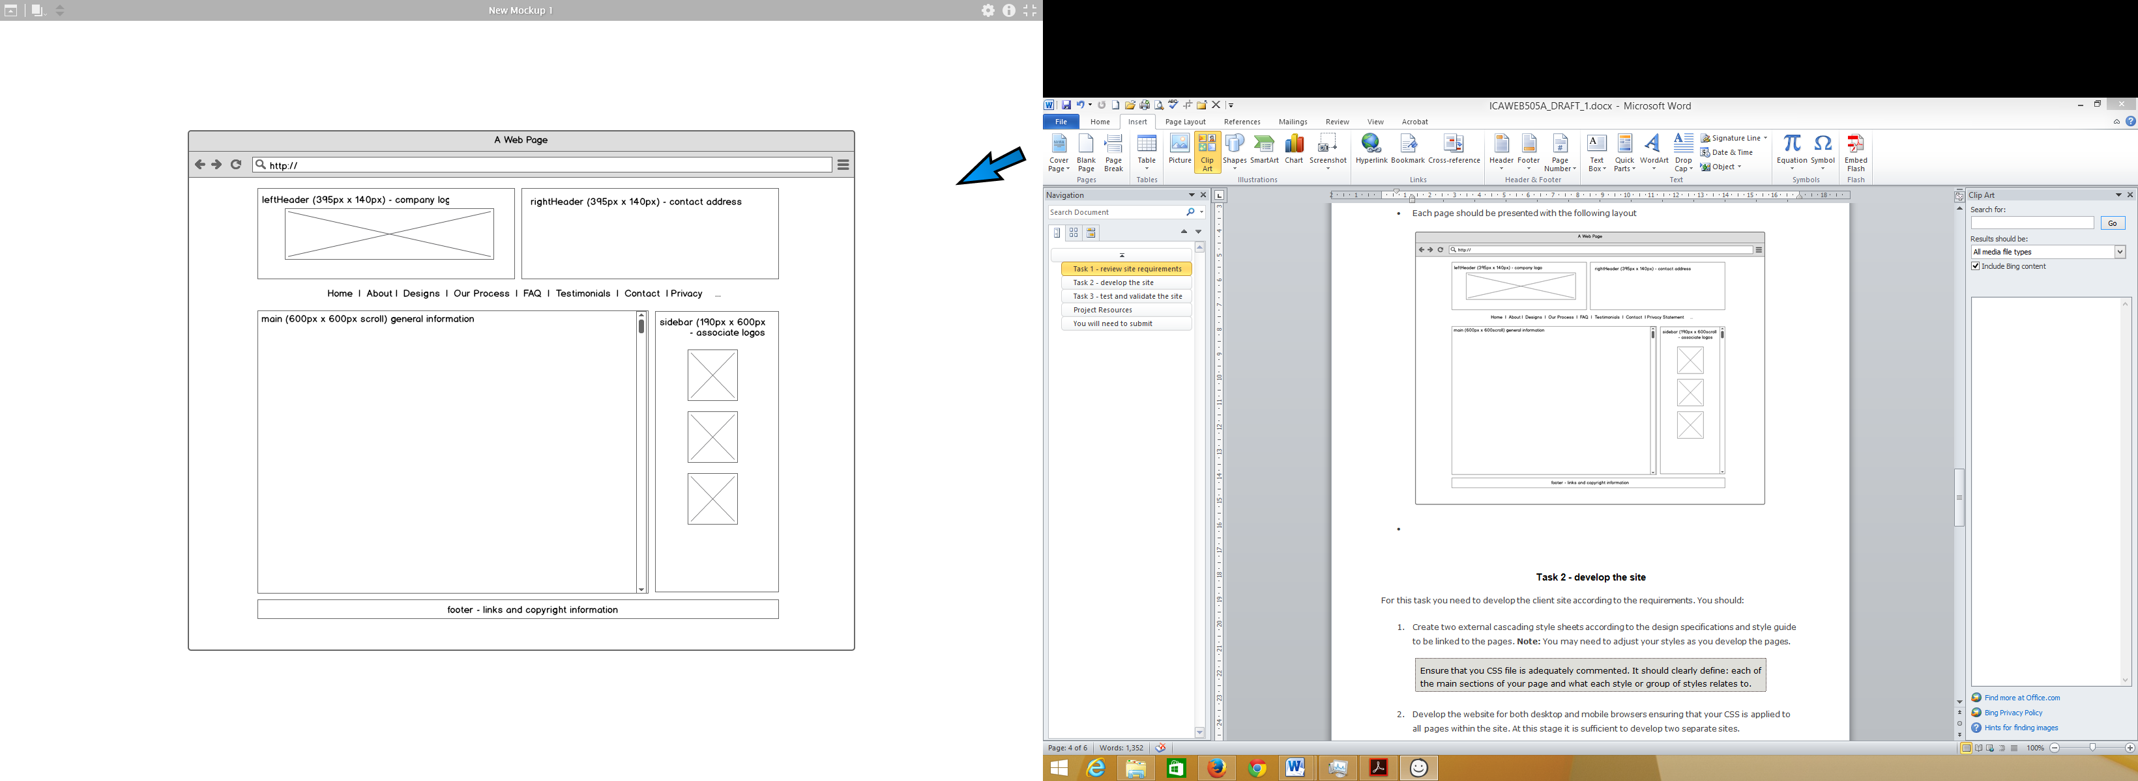

Figure : Wireframe mock-up of the desktop (res: > 801px)

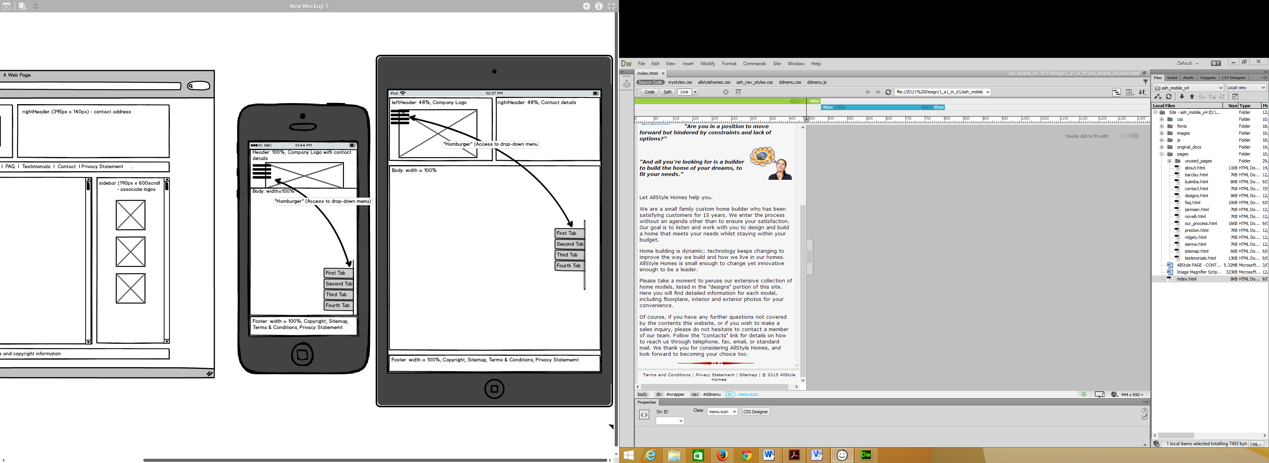 

Figure : Wireframe for Tablet (res: >480 & < 801px). Figure : Wireframe for Phone (res: < 481px)

* The website should adhere to the following guidelines which should be read in conjunction with the diagram above:

|  |  |
| --- | --- |
| **Note:** All styles should be implemented using CSS and NOT HTML tags | |
| Corporate colours | The AllStyle Homes corporate colors (as seen in the company logo) should be utilized for this site and selected from the list below:    These colours can be adjusted to suit visibility and contrast requirements if necessary. |
| Page layout | The mock-up image gives an indication as to the general layout of the page. The page content should be centred on the screen. The overall page background colour should be a light grey (#DFDFDF)  The main content background colour should be off-white (#F6F6F6). Other background colours, in keeping with the corporate colours, can be used in other sections of the site where appropriate. |
| Text | All text should be rendered in the following font set:  Verdana, but allowed to degrade to Arial, Helvetica, sans-serif.  All paragraph text should be left aligned and to the following specifications (***you may use line and word spacing for paragraphs as you deem appropriate***): |
| Hyperlinks | All hyperlink text should be rendered in the following font set:  Verdana, but allowed to degrade to Arial, Helvetica, sans-serif.  Hyperlinks should not be underlined except where specified. |
| Footer Hyperlinks | Footer hyperlinks should be rendered in the following font set:  Tahoma, but allowed to degrade to Geneva, sans-serif  The footer area should also contain a text menu (centred within the footer area) with each item separated by the | (pipe) character and with the following link specifications: |
| Images | Text should be appropriately aligned around images. |

The Technical Requirements were as follows:

|  |  |  |
| --- | --- | --- |
| **Element** | **Requirement** | **Example** |
| File naming convention | All lowercase alphanumeric up to 20 characters  Three/Four letter file type extensions  No spaces, an underscore for separation | jannsen_sm.jpg process.html  media_queries.css  ddmenu.js privacy_statement.pdf |
| Folder naming convention | Folders should be named to represent the contents of the folder eg: images  All lowercase up to 20 characters  No spaces, an underscore for separation | css pages images documents js |
| Browser compatibility | Internet Explorer 7+  Mozilla Firefox 10+  Google Chrome 17+ | [if lt IE 8]> ~ <![endif]  -moz- ; -ms- ; -webkit- |
| Browser plug-ins | No specific browser plug-ins required at this stage |  |
| File format to be used | Image files should be .gif, .jpg or .png as appropriate.  Pages should be .html |  |
| Document formats | All documents should be provided in PDF format | privacy_statement.pdf terms_and_conditions.pdf |
| Page download times | < 10 secs at 256kbps |  |
| Default screen resolution | 1024 x 768 pixels |  |
| Content accessibility | W3C Content Accessibility Guidelines 2.0 (WCAG 2.0) Level A  W3C Cascading Style Sheets Level 2 Revision 1 (CSS2.1) minimum | http://www.w3.org/TR/WCAG/  http://www.w3.org/TR/CSS2/ |
| Target Hardware | Systems capable of running these OS:  Windows XP and above  Apple Mac OS X |  |

Folder Structure

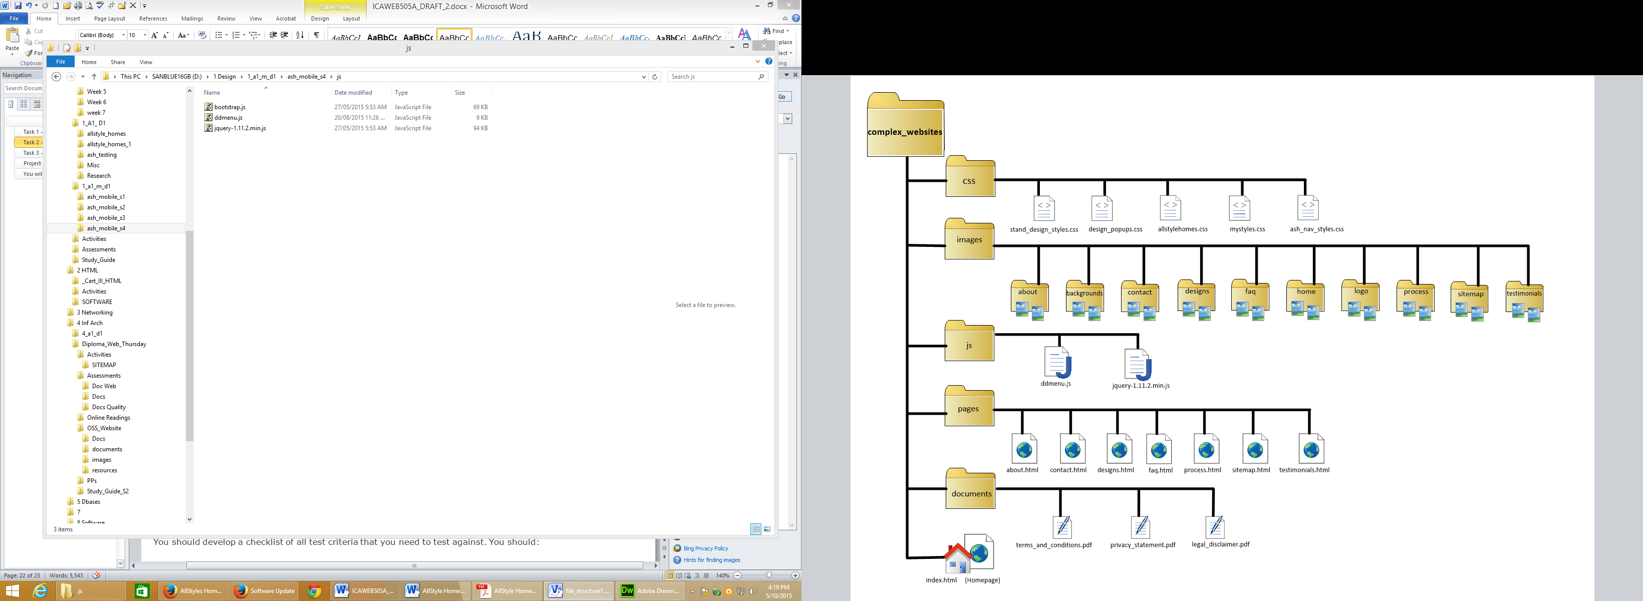

## Task 2 - develop the site

Write a brief report on how you have used CSS to achieve each of the requirements for the website such as imagemaps, text styles, navigation and layout.

|  |  |  |
| --- | --- | --- |
| **Code** | **Explanation** | |
| **mystyles.css**  @charset "utf-8";  body {  margin-top: 0px;  margin-bottom: 0px;  background-color: #dfdfdf;  }  #wrapper {  width: 800px;  height: auto;  margin-left: auto;  margin-right: auto;  margin-top: 10px;  font-family: Verdana, Arial, helvetica;  }  #leftHeader {  width: 396px;  height: 140px;  float: left;  background-color: #f6f6f6;  margin-right: 4px;  margin-bottom: 8px;  background-image: url(../images/logo/logo_390x140.png);  background-repeat: no-repeat;  background-size: 390px 140px;  background-position: center;  }  #rightHeader {  width: 306px;  height: 128px;  margin-left: 4px;  margin-bottom: 8px;  float: right;  background-color: #f6f6f6;  background-size: 305px 128px;  padding-top: 12px;  padding-right: 10px;*/  padding-left: 90px;  }  #main {  width: 580px;  max-height: 800px;  min-height: 800px;  background-color: #f6f6f6;  float: left;  margin-right: 5px;  margin-top: 8px;  margin-bottom: 10px;  padding: 10px;  overflow-y: scroll;  overflow-x: no-display;  }  #sidebar {  width: 180px;  height:800px;  background-color: #f6f6f6;  float: right;  margin-left: 5px;  margin-top: 8px;  margin-bottom: 10px;  padding-top: 10px;  padding-bottom: 10px;  padding-right: 5px;  padding-left: 5px;  }  #footer {  width: 790px;  clear: both;  background-color: #f6f6f6;  font-size:10px;  margin-top: 10px;  padding: 5px;  text-align: center;  }  @media (min-width: 481px) and (max-width: 801px){    #wrapper {  width: 100%;  margin-top: 10px;  height: auto;  font-family: Verdana, Arial, helvetica;  background-color:#dfdfdf;  }  #leftHeader {  width: 49.5%;  height: 140px;  float: left;  background-color: #f6f6f6;  margin-right: 0.4%;  margin-bottom: 2px;  padding: 0%;  background-image: url(../images/logo/logo_390x140.png);  background-size: 100% auto;  background-position: center;  background-repeat: no-repeat;  }  #rightHeader {  width: 38.45%;  height: 128px;  margin-left: 0.4%;  margin-bottom: 2px;  float: right;  background-color: #f6f6f6;  padding-top: 12px;  padding-left: 11.25%;  }  #main {  width: 100%;  height: auto;  background-color: #f6f6f6;  margin-top: 3px;  margin-bottom: 4px;  padding: 5px;  overflow-y: no-display;  overflow-x: no-display;  }  #sidebar {  display: none;  visibility: hidden;  }  #footer {  width: 100%;  background-color: #f6f6f6;  font-size:10px;  margin-top: 10px;  padding-top: 5px;  padding-right: 5px;  padding-bottom: 5px;  padding-left: 5px;  text-align: center;  }  }  @media (max-width: 480px){  #wrapper {  width: 100%;  margin-top: 10px;  height: auto;  font-family: Verdana, Arial, helvetica;  background-color:#dfdfdf;  }  #leftHeader {  width: 100%;  background-color: #f6f6f6;  margin-right: 5px;  margin-bottom: 10px;  padding-left: 5px;  background-image: url(../images/logo/logo_mobile.png);  background-size: 90%;  background-position: center;  background-repeat: no-repeat;  }  #rightHeader {  display: none;  visibility: hidden;  }  #main {  width: 100%;  height: auto;  background-color: #f6f6f6;  margin-top: 5px;  margin-bottom: 5px;  padding: 5px;  overflow-y: no-display;  overflow-x: no-display;  }  #sidebar {  display: none;  visibility:hidden;  }    #footer {  width: 100%;  background-color: #f6f6f6;  font-size:10px;  margin-top: 10px;  padding: 5px;  text-align: center;  }  } | The mystyles.css was used to configure the basic structure/layout of the site  The “body”:  Background colour (for around the content area) was set  The “wrapper”:   * Width set to 800px * Height set to “auto” (as long as required) * The wrapper was centered on the screen * Font for the whole site was set as Verdana, etc   The “leftHeader”:   * Width and height set to specific pixels * The container was set to left side of screen * Background colour set * Margins set * Background image (company logo) set * “no-repeat” = only appears once * Specific image size set to specific pixels * Logo is centred in the container   The “rightHeader”:   * Width and height set to specific pixels * Margins set to specific pixels * Container was set to right side of leftHeader * Padding set to specific pixels   NOTE: Navigation Bar is configures in a separate style sheet called “ddmenu.css”  The “main”:   * Width set to 580px * A max & min heights were set to ensure both short & long screens would be in same size area * Background colour set again * Container set to the left-hand side * Margins set * A vertical scroll bar set for “long” pages to fit * No horizontal scroll set. Instead uses word-wrap   The “sidebar”:   * Width and height set to specific pixels * Background colour set again * The container was set to right side of screen * Margins set * Padding set   The “footer”   * Width set to 790px (ie to width of the wrapper) * Set to clear (ie sit below) two containers above * Background colour set again * Font size set to 10 pixels * Margin set * Padding set * Text set to be centred in the container   Media query set for tablet devices of specified width  Note: Modifications to original configurations.  The “wrapper”:   * Width set to 100% of screen ie no space * Margin set * Height set to “auto” (as long as required) * Font set to Verdana, etc   The leftHeader”:   * Width set to 49.5% of the screen * Height set * The container was set to left side of screen * Background colour set * Margins set as percentage of the screen width * Background image (company logo) set * Image size set to width of 100% and height auto * Logo is centred in the container * “no-repeat” = only appears once   The “rightHeader”:   * Width set as a percentage of the screen width * Height set to specific pixels * Margins set as a percentage of screen width * The container was set to right side of leftHeader * Background colour set * Padding set   NOTE: Navigation Bar is configured in a separate style sheet called “ddmenu.css”  The “main”:   * Width set to 100% of the screen width * Height set to “auto” (long as required) * Background colour set * Margins set as pixels * Padding set * The container will have neither vertical nor horizontal scroll bars ie. Content will “flow” indefinitely   NOTE: The sidebar has been removed for the mobile devices  The “footer”:   * Width has been set to 100% of the screen width * Background colour set * Font size set to 10 pixels * Margins set as pixels * Padding set * Text will be centered on the screen   End of media query  Media query set for mobile-phone of specified width  Note: Modifications to original configurations.  The “wrapper”:   * Width set to 100% of screen ie no space * Margin set * Height set to “auto” (as long as required) * Font set to Verdana, etc * Background colour set   The leftHeader”: (NOTE: Only one header)   * Width set to 100% of the screen * Background colour set * Margins set as percentage of the screen width * Background image (company mobile logo) set * Image size set to width of 90% of container * Logo is centred in the container * “no-repeat” = only appears once   NOTE: There is no rightHeader  NOTE: Navigation Bar is configures in a separate style sheet called “ddmenu.css”  The “main”:   * Width set to 100% of the screen width * Height set to “auto” (long as required) * Background colour set * Margins set as pixels * Padding set * The container will have neither vertical scroll bar (ie. Content will “flow” indefinitely) nor horizontal scroll bars (utilising word-wrap)   NOTE: The sidebar has been removed for the mobile devices  The “footer”:   * Width has been set to 100% of the screen width * Background colour set * Font size set to 10 pixels * Margins set as pixels * Padding set * Text will be centered on the screen   End of media query | |
| **allstylehomes.css**  @charset "utf-8";  /* Formats text/fonts */  p {  text-align: left;  font-size: 12pt;  font-family:Verdana, Arial, helvetica, san serif;  color: #000000;  }  .h1 {  text-align: left;  font-style: strong;  font-size: 24pt;  font-weight: 800;  text-decoration: underline;  letter-spacing: -2px;  color: #b40c00;  }  .h2 {  text-align: left;  font-size: 20pt;  font-weight: 700;  color: #b40c00;  }  .h3 {  text-align: left;  font-size: 16pt;  font-weight: 600;  color: #e86600;  }  .h4 {  font-size: 10pt;  }  .h5 {  text-align: left;  font-size: 16pt;  font-weight: 500;  color: #000000;  }  .c2 {  text-align: center;  }  p.questions {  font-family: Verdana, Arial, helvetica, sans-serif;  font-size: 17px;  font-weight: 800;  font-style: italic;  /*text-indent: 50px;*/  }  .faqquestions {  font-family: Verdana, Arial, helvetica, sans-serif;  font-size: 17px;  font-weight: 800;  font-style: italic;  color: #e86600;  }  .statement {  font-family: Verdana, Arial, helvetica, sans-serif;  font-size: 12pt;  font-weight: 500;  font-style: italic;  padding-left: 30px;  padding-right: 30px;  text-align: justify;  }  .txtindent {  font-family: Verdana, Arial, helvetica, sans-serif;  font-size: 12pt;  font-weight: 500;  padding-left: 30px;  text-align: justify;  }  p.cl {  font-family: Verdana, Arial, helvetica, sans-serif;  font-size: 12pt;  font-weight: 500;  color: #e86600;  }  .clbold {  font-family: Verdana, Arial, helvetica, sans-serif;  font-size: 12pt;  font-weight: 600;  color: #e86600;  }  .bo {  font-family: Verdana, Arial, helvetica, sans-serif;  font-size: 12pt;  font-weight: 700;  }  /* Indents and justifies unordered-list for Value Statements */  ul.valu_ullist {  margin-left: 40px;  margin-bottom: 45px;  list-style-position: outside;  text-align: justify;  }  li.valu_lilist{  margin-top: 10px;  margin-right: 30px;  }  ul.process {  color: #e86600;  }  ol.process {  color: #e86600;  }  ul.sitemap {  line-height: 20px;  }  ul.dimentions {  list-style-type:none; /*remove the bullet point*/  margin-left:0;  }  /* Formats heading (as per logo) in side bar*/  .t_black {  color: #000000;  font-size:20px;  }  .t_tan {  color: #b40c00;  font-size: 22px;  }  /* Centres images/logos in sidebar */  img.center {  display: block;  margin-left: auto;  margin-right: auto;  margin-top: 10px;  margin-bottom: 10px;  width: 119px;  height: auto;  border-style: solid;  border-width: 1px;  border-color: #000000;  }  img.center2 {  display: block;  margin-left: auto;  margin-right: auto;  margin-top: 10px;  margin-bottom: 10px;  width: 300px;  height: auto;  border-style: solid;  border-width: 1px;  border-color: #000000;  }  img.large {  display: block;  margin-left: auto;  margin-right: auto;  margin-top: 10px;  margin-bottom: 10px;  width: 95%;  height: auto;  border-style: solid;  }  img.plan {  width: 100%;  float: left;  margin-right: 10px;  margin-top: 15px;  }  /* Formats & positions spacer image in main & sidebar */  img.textspacer1 {  display: block;  margin-left: auto;  margin-right: auto;  margin-top: 5px;  margin-bottom: 5px;  width: 50%;  height: auto;  }  img.sidespacer {  display: block;  margin-left: auto;  margin-right: auto;  margin-top: 20px;  margin-bottom: 20px;  width: 100px;  height: 6px;  }  .gmap {  border-style: solid;  border-width: 10px;  border-color: #000000;  }  /* Positions images - left & right justified - in main */  .img_left {  float: left;  width: 40%;  height: auto;  margin-top: 15px;  margin-right: 15px;  }  .img_right {  float: right;  width: 40%;  height: auto;  margin-left: 15px;  }  /*  /* Format links in the navigation bar*/  a.class1:link {  color: #b40c00;  background-color: transparent;  text-decoration: none;  }  a.class1:visited {  color: #e86600;  background-color: transparent;  text-decoration: none;  }  a.class1:hover {  color: #b40c00;  background-color: transparent;  text-decoration: underline;  }  a.class1:active {  color: #e86600;  background-color: transparent;  text-decoration: underline;  }  /* Format links in the footer*/  a.class2:link {  color: #000000;  background-color: transparent;  text-decoration: none;  }  a.class2: visited {  color: #e86600;  background-color: transparent;  text-decoration: none;  }  a.class2: hover {  color: #b40c00;  background-color: transparent;  text-decoration: underline;  }  a.class2: active {  color: #b40c00;  background-color: transparent;  text-decoration: underline;  }  #plan {  width: 55%;  float: left;  margin-right: 5px;  margin-top: -25px  }  #dimensions {  width: 40%;  padding-left: 10px;  float: right;  }  #features {  width: 45%;  padding-left: 10px;  float: left;  clear:both;  }  #inclusions {  width: 45%;  padding-left: 10px;  float: right;  }  #design_thumbs {  width: 482px;  height: auto;  margin-right: auto;  margin-left: auto;  }  @media (min-width: 481px) and (max-width: 801px){  p {  text-align: left;  font-size: 11pt;  font-family:Verdana, Arial, helvetica, san serif;  color: #000000;  }  .h1 {  text-align: left;  font-style: strong;  font-size: 20pt;  font-weight: 700;  text-decoration: underline;  letter-spacing: -2px;  color: #b40c00;  }  .h2 {  text-align: left;  font-size: 18pt;  font-weight: 600;  color: #b40c00;  }  .h3 {  text-align: left;  font-size: 14pt;  font-weight: 600;  color: #e86600;  }  .h4 {  font-size: 9pt;  }  .h5 {  text-align: left;  font-size: 14pt;  font-weight: 500;  color: #000000;  }  .c2 {  text-align: center;  }  p.questions {  font-family: Verdana, Arial, helvetica, sans-serif;  font-size: 15px;  font-weight: 800;  font-style: italic;  }  .faqquestions {  font-family: Verdana, Arial, helvetica, sans-serif;  font-size: 15px;  font-weight: 800;  font-style: italic;  color: #e86600;  }  .statement {  font-family: Verdana, Arial, helvetica, sans-serif;  font-size: 11pt;  font-weight: 500;  font-style: italic;  padding-left: 20px;  padding-right: 20px;  text-align: justify;  }  .txtindent {  font-family: Verdana, Arial, helvetica, sans-serif;  font-size: 11pt;  font-weight: 500;  padding-left: 20px;  text-align: justify;  }  p.cl {  font-family: Verdana, Arial, helvetica, sans-serif;  font-size: 11pt;  font-weight: 500;  color: #e86600;  }  .clbold {  font-family: Verdana, Arial, helvetica, sans-serif;  font-size: 11pt;  font-weight: 600;  color: #e86600;  }  .bo {  font-family: Verdana, Arial, helvetica, sans-serif;  font-size: 11pt;  font-weight: 700;  }  /* Indents and justifies unordered-list for Value Statements */  ul.valu_ullist {  colour: red;  margin-left: 30px;  margin-bottom: 30px;  list-style-position: outside;  text-align: justify;  }  li.valu_lilist{  margin-top: 7px;  margin-right: 20px;  }  /* Positions images - left & right justified - in main */  .img_left {  float: left;  width: 32%;  height: auto;  margin-top: 10px;  margin-right: 10px;  }  .img_right {  float: right;  width: 32%;  height: auto;  margin-left: 10px;  }  .img_popup {  width: 60%;  height: auto;  }  enlarge.popup_sm {  width: 60%;  height: auto;  }  #design_thumbs {  width: 482px;  height: auto;  margin-right: auto;  margin-left: auto;  }  #plan {  width: 45%;  float: left;  margin-right: 5px;  margin-top: -25px  }  #dimensions {  width: 50%;  padding-left: 10px;  float: right;  }  #features {  width: 45%;  padding-left: 10px;  float: left;  clear:both;  }  #inclusions {  width: 45%;  padding-left: 10px;  float: right;  }  }  @media (max-width: 480px){    /* Positions images - left & right justified - in main */  .img_left {  float: left;  width: 28%;  height: auto;  margin-top: 5px;  margin-right: 5px;  }  .img_right {  float: right;  width: 28%;  height: auto;  margin-left: 5px;  }  p {  text-align: left;  font-size: 10pt;  font-family:Verdana, Arial, helvetica, san serif;  color: #000000;  }  .h1 {  text-align: left;  font-style: strong;  font-size: 18pt;  font-weight: 800;  text-decoration: underline;  letter-spacing: -2px;  color: #b40c00;  }  .h2 {  text-align: left;  font-size: 16pt;  font-weight: 700;  color: #b40c00;  }  .h3 {  text-align: left;  font-size: 12pt;  font-weight: 600;  color: #e86600;  }  .h4 {  font-size: 10pt;  }  .h5 {  text-align: left;  font-size: 12pt;  font-weight: 500;  color: #000000;  }  .c2 {  text-align: center;  }  p.questions {  font-family: Verdana, Arial, helvetica, sans-serif;  font-size: 13px;  font-weight: 700;  font-style: italic;  /*text-indent: 50px;*/  }  .faqquestions {  font-family: Verdana, Arial, helvetica, sans-serif;  font-size: 13px;  font-weight: 700;  font-style: italic;  color: #e86600;  }  .statement {  font-family: Verdana, Arial, helvetica, sans-serif;  font-size: 10pt;  font-weight: 400;  font-style: italic;  padding-left: 15px;  padding-right: 30px;  text-align: justify;  }  .txtindent {  font-family: Verdana, Arial, helvetica, sans-serif;  font-size: 10pt;  font-weight: 400;  padding-left: 15px;  text-align: justify;  }  p.cl {  font-family: Verdana, Arial, helvetica, sans-serif;  font-size: 10pt;  font-weight: 400;  color: #e86600;  }  .clbold {  font-family: Verdana, Arial, helvetica, sans-serif;  font-size: 10pt;  font-weight: 500;  color: #e86600;  }  .bo {  font-family: Verdana, Arial, helvetica, sans-serif;  font-size: 10pt;  font-weight: 600;  }  /* Indents and justifies unordered-list for Value Statements */  ul.valu_ullist {  colour: red;  margin-left: 25px;  margin-bottom: 25px;  list-style-position: outside;  text-align: justify;  }  li.valu_lilist{  margin-top: 4px;  margin-right: 15px;  }  #design_thumbs {  width: 340px;  height: auto;  margin-right: auto;  margin-left: auto;  }  #plan {  width: 75%;  height: auto;  float: left;  margin-left: auto;  margin-right: auto;  margin-top: -25px  }  #dimensions {  width: 100%;  height: auto;  padding-left: 0px;  margin-left: 10px;  float: left;  clear: left;  font-size: 14;  }  #features {  width: 100%;  height: auto;  padding-left: 0px;  margin-left: 10px;  float: left;  clear:left;  font-size: 14px;  }  #inclusions {  width: 100%;  height: auto;  padding-left: 0px;  margin-left: 10px;  float: left;  clear:left;  font-size: 14px;  }  } | The allstylehomes.css was used to configure the texts and images  Formats the paragraph text throughout the document  Classes to formats the “title” fonts h1 to h5 (largest to smallest  Class to align text as centered  Class to format the paragraph text; specifically the questions on the homepage which were large, bold and italic  Class to format the text; specifically the questions on the faq page which were large, bold, italic and of a specific colour  Class to format the text; specifically the quoted testimonials on the testimonial page which were slightly bold, italic, indented (left & right) and left/right justified  Class to format the text; specifically the answers on the faq page which were slightly bold, indented and left/right justified  Class to format the text; to a specific font-weight (boldness) bold and colour  Class to format the text; to a specific font-weight (boldness) bold and colour  Class to format the text; to a specific font-weight (boldness) bold and colour  Class that formats an unordered list; specifically indents the list, places the bullet-point outside the paragraph and then left/right justifies the paragraph.  Class that formats an unordered list; specifically sets the font colour  Class that formats an ordered list; specifically sets the font colour  Class that formats an unordered list; specifically sets the line height  Class that formats an unordered list; specifically to remove the bullet-points  Class used to type text similar to the logo text in size and colour  Class used to type text similar to the logo text in size and colour  Class to centres the images/logos in sidebar  Class used to centre the large illustration in the contact page and the architectural image on each individual home design page  Class used to configure the architectural image (plan) on each individual home design page   * Width set to 100% of container * Image positioned to the left side of coctainer   Class to format the spacer/divider image in the main div   * Width is set to 50% of the container * Spacer is centred in the container   Class to format the spacer/divider image in the sidebar   * Width is set to 100 pixels * Spacer is centred in the container   Class to position image on homepage   * Position to the left side * Set width to 40 of container * Set height to “auto” * Set margins   Class to position image on homepage   * Position to the right side * Set width to 40 of container * Set height to “auto” * Set margins   No longer in use  Classes to format the anchor hyperlinks in the footer   * The link, in normal state * The link after being clicked * The link with the cursor placed above it * As an active link   The container for the architectural drawing (plan) of each house design on each design page   * Width set to 55% of the main container * Positioned to the left side of the main container * Margins set   The container for the list of dimensions/areas of each house design on each design page   * Width set to 40% of the main container * Margins set * Positioned to the right side of the main container   The container for the list of features of each house design on each design page   * Width set to 45% of the main container * Padding set * Positioned to the left side of the main container * Set to clear (ie sit below) two containers above   The container for the list of inclusions of each house design on each design page   * Width set to 45% of the main container * Padding set * Positioned to the right side of main container   The container for the thumb-nail images of the individual houses on the design page   * Width set to 482 pixels * Height set to “auto” * Container is centred in the main container   Media query set for mobile-phone of specified width  Note: Modifications to original configurations.  Formats the paragraph text throughout the document  Classes to formats the “title” fonts h1 to h5 (largest to smallest  Class to align text as centered  Class to format the paragraph text; specifically the questions on the homepage which were large, bold and italic  Class to format the text; specifically the questions on the faq page which were large, bold, italic and of a specific colour  Class to format the text; specifically the quoted testimonials on the testimonial page which were slightly bold, italic, indented (left & right) and left/right justified  Class to format the text; specifically the answers on the faq page which were slightly bold, indented and left/right justified  Class to format the text; to a specific font-weight (boldness) bold and colour  Class to format the text; to a specific font-weight (boldness) bold and colour  Class to format the text; to a specific font-weight (boldness) bold and colour  Class that formats an unordered list; specifically indents the list, places the bullet-point outside the paragraph and then left/right justifies the paragraph.  Class that formats an unordered list; specifically sets the font colour  Class to position image on homepage   * Position to the left side * Set width to 40 of container * Set height to “auto” * Set margins   Class to position image on homepage   * Position to the right side * Set width to 40 of container * Set height to “auto” * Set margins   The container for the thumb-nail images of the individual houses on the design page   * Width set to 482 pixels * Height set to “auto” * Container is centred in the main container   The container for the architectural drawing (plan) of each house design on each design page   * Width set to 45% of the main container * Positioned to the left side of the main container * Margins set   The container for the list of dimensions/areas of each house design on each design page   * Width set to 50% of the main container * Margins set * Positioned to the right side of main container   The container for the list of features of each house design on each design page   * Width set to 45% of the main container * Padding set * Positioned to the left side of the main container * Set to clear (ie sit below) two containers above   The container for the list of inclusions of each house design on each design page   * Width set to 45% of the main container * Padding set * Positioned to the right side of main container   Close Media Query  Media Query set for mobile-phone of specified width  Note: Modifications to original configurations.  Class to position image on homepage   * Position to the left side * Set width to 40 of container * Set height to “auto” * Set margins   Class to position image on homepage   * Position to the right side * Set width to 40 of container * Set height to “auto” * Set margins   Formats the paragraph text throughout the document  Classes to formats the “title” fonts h1 to h5 (largest to smallest  Class to align text as centered  Class to format the paragraph text; specifically the questions on the homepage which were large, bold and italic  Class to format the text; specifically the questions on the faq page which were large, bold, italic and of a specific colour  Class to format the text; specifically the quoted testimonials on the testimonial page which were slightly bold, italic, indented (left & right) and left/right justified  Class to format the text; specifically the answers on the faq page which were slightly bold, indented and left/right justified  Class to format the text; to a specific font-weight (boldness) bold and colour  Class to format the text; to a specific font-weight (boldness) bold and colour  Class to format the text; to a specific font-weight (boldness) bold and colour  Class that formats an unordered list; specifically indents the list, places the bullet-point outside the paragraph and then left/right justifies the paragraph.  Class that formats an unordered list; specifically sets the font colour  The container for the thumb-nail images of the individual houses on the design page   * Width set to 482 pixels * Height set to “auto” * Container is centred in the main container   The container for the architectural drawing (plan) of each house design on each design page   * Width set to 75% of the main container * Positioned to the left side of the main container * Margins set   The container for the list of dimensions/areas of each house design on each design page   * Width set to 100% of the main container * Margins set * Positioned to the left side of main container * Set to clear (ie sit below) two containers above * Font-size changes   The container for the list of features of each house design on each design page   * Width set to 100% of the main container * Padding set * Margins * Positioned to the left side of the main container * Set to clear (ie sit below) two containers above * Font-size changes   The container for the list of inclusions of each house design on each design page   * Width set to 100% of the main container * Padding set * Margins set * Positioned to the left side of main container * Set to clear (ie sit below) two containers above * Font-size changes   Close Media Query | |
| **ddmenu.css**  @charset "utf-8";  /* main menu ----------------------------*/  #ddmenu {  display: block;  font-family: "Helvetica Neue", Helvetica, Arial, sans-serif;  text-align: center; /*Specify the alignment of the whole UL if UL is not width:100%;*/  letter-spacing: normal;  width:100%;  }  #ddmenu ul {  margin:0 auto;  padding: 0;  text-align: center; /* Alignment of each top-level menu items within the UL */  width: 100%;  margin-left:auto;  margin-right:auto;  font-size: 0;  background: #b40c00;  display: inline-block;  list-style: none;  position: relative;  z-index: 999;  border:none;  border-radius:2px;  }  #ddmenu li {  margin:0;  padding:0;  font-size: 12px;  display: inline-block;  *display: inline;  zoom: 1; /*for IE6-7*/  position: relative;  color: #EEE;  line-height: 30px; /*This determines the height of the menu*/  transition: background-color 0.2s;  outline:none;  -moz-user-select:none;  -webkit-user-select: none;  -ms-user-select: none;  }  #ddmenu li.full-width {  position: static;  }  #ddmenu li.over {  color:#FFF;  background-color: rgba(255,255,255,0.35);  background-color: #999 \9; /*fallback for old IE*/  }  #ddmenu li.over.no-sub {    }  #ddmenu .top-heading {  font-weight: bold;  white-space: nowrap;  margin:0 22px;  color: inherit;  text-decoration: none;  display:inline-block;  outline: 0;  cursor: pointer;  }  /* links of top-heading */  #ddmenu li a, #ddmenu li a:link, #ddmenu li a:hover  {  color: inherit;  }  #ddmenu li a:hover  {  text-decoration:underline;  }  #ddmenu li a:focus  {  outline:1px dotted #09F;  }  /* caret(arrow icon) */  #ddmenu i.caret {  color: inherit;  left:-18px;  width: 0;  height: 0;  overflow: hidden; /*for IE6*/  vertical-align: middle;  margin-bottom: 2px;  border-top: 4px solid; /*caret size is 4px now*/  border-right: 4px solid transparent;  border-left: 4px solid transparent;  display: inline-block;  position:relative;  }  /* sub-menu layout ----------------------------*/  #ddmenu .dropdown {  width: 220px;  left: 0px;  color: #000000;  padding:0;margin:0;display:none;position:absolute;  top: 100%;  border:1px solid ;  border-top:none;  border-radius:0 0 4px 4px;  background-color: rgba(180,12,0,0.51);  background-color: #7691b4 \9; /*fallback for old IE*/  }  #ddmenu li.full-width .dropdown {  width: 100%;  padding: 0;  margin: 0;  }  #ddmenu .offset300 {  left: -300px;right:auto;  }  #ddmenu .right-aligned {  left: auto;  right: 0px;  }  #ddmenu li.over .dropdown {  display: block;  }  #ddmenu .dd-inner {  text-align: center;  padding: 20px;  margin:16px;  background-color: #FFF;  white-space: nowrap;  font-size: 13px;  line-height:1.35;  }  /* links in sub menu ----------------------------*/  #ddmenu .dropdown a {  display:table-row;  *display:block;  color: #333333;  line-height: 22px;  text-decoration: none;  padding: 0;  }  #ddmenu .dropdown a:hover, #ddmenu .dropdown a:focus {  text-decoration: underline;  color: #b40c00;  }  /* blocks within the sub-menu -----------------------------*/  #ddmenu div.column {  text-align: left;  vertical-align: top; /*or middle*/  display: inline-block;  *display: inline;*zoom: 1;  white-space:normal;  width:200px;  padding:0 30px;  border-right:1px solid #999;  }  #ddmenu div.dd-inner div:last-child {  border-right: none;  }  #ddmenu div.column h3 {  font-weight: 500;  line-height: 1.1;  margin-top: 12px;  margin-bottom: 8px;  font-size: 24px;  }  #ddmenu li {  border-left:1px solid #e86600;  border-right:1px solid #e86600; }  #ddmenu li:first-child {border-left:none;}  #ddmenu li:last-child {border-right:none;}  #ddmenu div.column260 {width:260px;}  #ddmenu div.column340 {width:340px;}  /* useful when http://www.menucool.com/ddmenu/one-menu-for-all-pages */  #ddmenuLink {display:none;}  /*######## add additional styles for mobile-friendly responsive menu ########*/  #ddmenu div.menu-icon {  display: none; /* hide menu icon initially */  }  /*  /*styles for responsive menu  @media only screen and (min-width: 481px) and (max-width: 801px) {    #ddmenu li div.column.mayHide {  display: none;  }  #ddmenu ul {  width: 100%;  border-radius: 0;  }  #ddmenu li {  position:relative;  width:33.33%;  box-sizing:border-box;  text-align: left;  border-top:1px solid rgba(255,255,255,0.3);  border-right:1px solid rgba(255,255,255,0.3);  }  #ddmenu li.full-width {  position: relative;  }  #ddmenu div.dropdown {  width: auto;  left: 0px;  text-align: left;  }  #ddmenu li.full-width div.dropdown {  width: auto;  }  #ddmenu div.dropdown.right-aligned, #ddmenu div.dropdown.mayRight {  left: auto;  right: 0px;  }  #ddmenu li div.column {  width: auto;  border: none;  }  }  */  /*styles for responsive menu*/  @media only screen and (min-width: 481px) and (max-width: 801px) {  #ddmenu li div.column.mayHide {  display: none;  }  /*override the original settings*/  #ddmenu ul {  width: 250px;  float: left;  display: none;  border-radius: 0;  }  #ddmenu li {  position: relative;  display: block;  font-size: 20px;  text-align: left;  border-bottom: 1px solid rgba(255,255,255,0.2);  }  #ddmenu li.full-width {  position: relative;  }  #ddmenu li .dropdown {  position: relative;  *top: auto; /*for IE7*/  border: none;  border-radius: 0;  box-shadow: none;  text-align: left;  background-color: #FFF;  }  #ddmenu .offset300 {  left: 0;  }  #ddmenu li.full-width div.dropdown {  width: auto;  }  #ddmenu .dd-inner {  margin:0;  background:none;  text-align:left;  }  /*turn column to list vertically instead of horizontally */  #ddmenu li div.column {  width:auto;  padding:0;  border:none;  display:block;  }  /*move the arrow icon to right*/  #ddmenu i.caret {  position:absolute;  left:auto;  right:14px;  top: 22px;  border-width:5px;  }  /* All the following are for the div.menu-icon (pure CSS) */  #ddmenu div.menu-icon {  font-size: 32px; /*icon size*/  display: block;  position: relative;  width: 40px;  height: 36px;  text-align: center;  cursor: pointer;  -moz-user-select: none;  -webkit-user-select: none;  background-color: #EEE;  border-radius: 3px;  margin-bottom:6px;  /*align the icon to the left*/  margin-left: 12px;  margin-right: auto;  }  #ddmenu div.menu-icon::before {  content: "";  position: absolute;  top: 0.25em;  left: 4px;  width: 1em;  height: 0.125em;  border-top: 0.375em double #b40c00;  border-bottom: 0.125em solid #b40c00;  box-sizing: content-box;  }  #ddmenu div.menu-icon-active {  background-color: #b40c00;  }  #ddmenu div.menu-icon-active::before {  border-color: #e86600;  }  }  /*styles for mobile*/  @media only screen and (max-width: 480px) {  #ddmenu li div.column.mayHide {  display: none;  }  /*override the original settings*/  #ddmenu ul {  width: 250px;  display: none;  border-radius: 0;  }  #ddmenu li {  position: relative;  display: block;  font-size: 20px;  text-align: left;  border-bottom: 1px solid rgba(255,255,255,0.2);  }  #ddmenu li.full-width {  position: relative;  }  #ddmenu li .dropdown {  position: relative;  *top: auto; /*for IE7*/  border: none;  border-radius: 0;  box-shadow: none;  text-align: left;  background-color: #FFF;  }  #ddmenu .offset300 {  left: 0;  }  #ddmenu li.full-width div.dropdown {  width: auto;  }  #ddmenu .dd-inner {  margin:0;  background:none;  text-align:left;  }  /*turn each column to list vertically instead of horizontally */  #ddmenu li div.column {  width:auto;  padding:0;  border:none;  display:block;  }  /*move the arrow icon to right*/  #ddmenu i.caret {  position:absolute;  left:auto;  right:14px;  top: 22px;  border-width:5px;  }  /* All the following are for the div.menu-icon (pure CSS) */  #ddmenu div.menu-icon {  font-size: 32px; /*icon size*/  display: block;  position: relative;  width: 40px;  height: 36px;  text-align: center;  cursor: pointer;  -moz-user-select: none;  -webkit-user-select: none;  background-color: #EEE;  border-radius: 3px;  margin-bottom:6px;  /*align the icon to the left*/  margin-left: 12px;  margin-right: auto;  }  #ddmenu div.menu-icon::before {  content: "";  position: absolute;  top: 0.25em;  left: 4px;  width: 1em;  height: 0.125em;  border-top: 0.375em double #b40c00;  border-bottom: 0.125em solid #b40c00;  box-sizing: content-box;  }  #ddmenu div.menu-icon-active {  background-color: #b40c00;  }  #ddmenu div.menu-icon-active::before {  border-color: #e86600;  }  } | | The ddmenu.css was used to configure the navigation/drop-down menu which is responsive to screen size/resolution.  #ddmenu is the div containing the navigation   * Displays the element as a block element * Sets div width at 100% of container   Configures the unordered list within the ddmenu div  Padding set   * Text is aligned centre * Width set to 100% of the container * Div is centred * Background colour set * Inline-block – elements side-by-side * Removes the bullet-points from the list * Position – relative * z-index – set to level 999 (“top of pile”)   Configures the list item   * Margin set * Padding set * Font size set * Inline-block – elements side-by-side * Script for earlier version of IE * Line height set * Transition time set to 0.2sec   Class called ‘full-width’ for list items   * Position set as static   Class called ‘over’ for list items   * Font colour set to white * Colour specifying opacity   Class called ‘top-heading’ for everthing in the ddmenu   * Sequences of whitespace will collapse into a single whitespace. Text will never wrap to the next line. The text continues on the same line * Inherit font colour from parent element * Plain text * Inline-block – elements side-by-side * The cursor is a pointer and indicates a link   For all link aspects   * Inherit font colour from parent element   For the hover aspect of a link   * Place an underline beneath text   For focus   * Place coloured dotted line   Configures the “caret” (icon to signify item with a dropdown menu  Configures the appearance of the drop-down menu  Class called ‘dropdown’ for list items governed by a class called ‘full-width’ , within the div  Class called ‘offset300’ within the div  Cass called ‘right-aligned’  Class called ‘dropdown’ for list items governed by a class called ‘over’ , within the div  Class called ‘dd-inner’ |

## Task 3 - test and validate the site

For this task you are required to test the website and rectify any inconsistencies or issues with the site. You should develop a checklist of all test criteria that you need to test against. You should:

1. Test the website across a number of different browsers to ensure consistency of presentation, (submit these as screen shots)

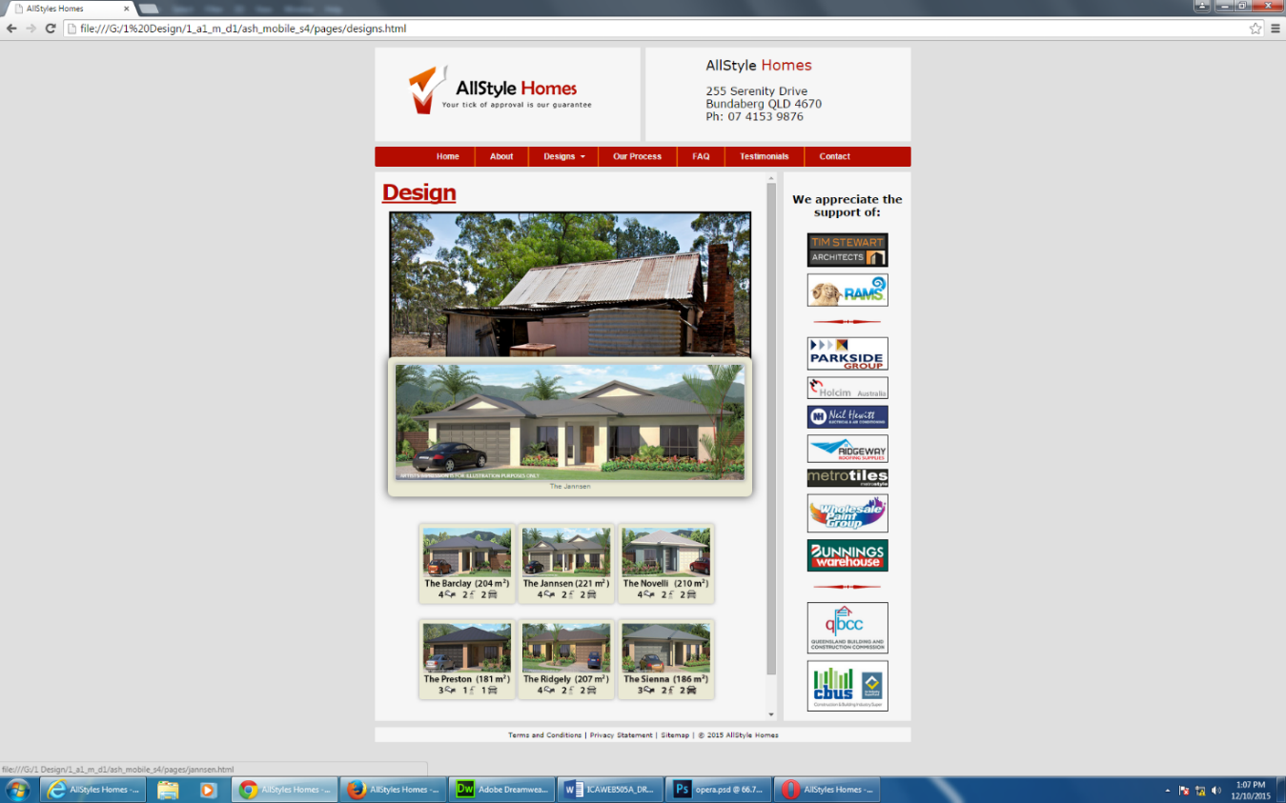

Figure : Designs page in Chrome browser

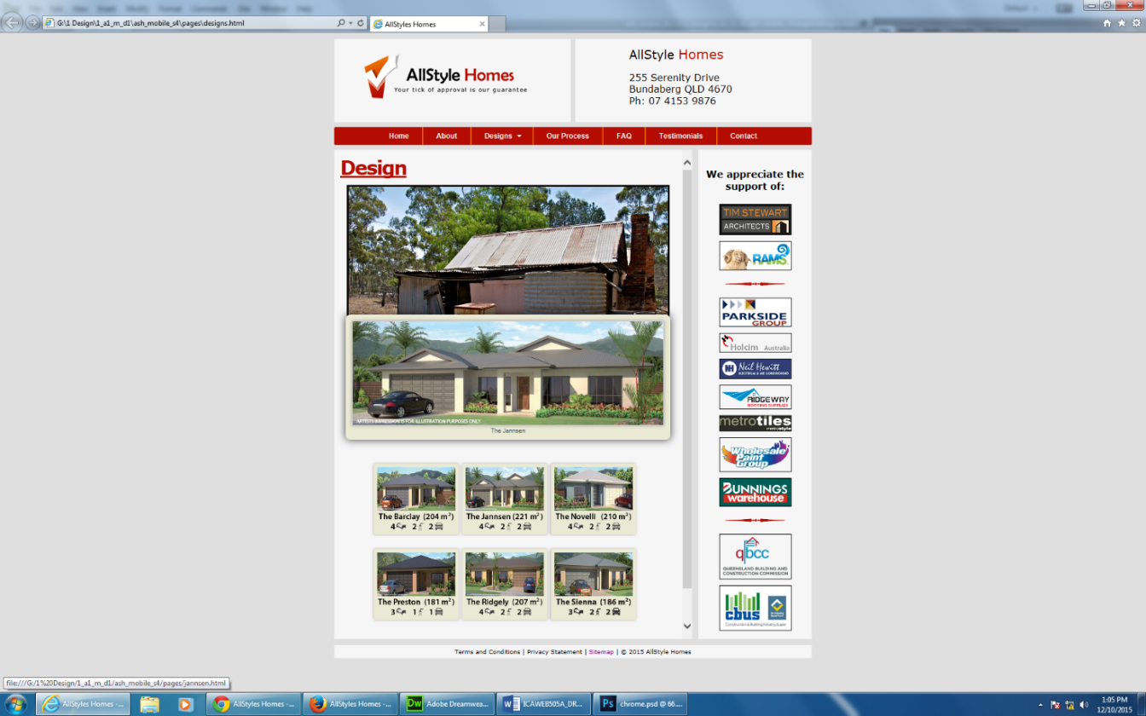

Figure : Designs page in Internet Explorer browser

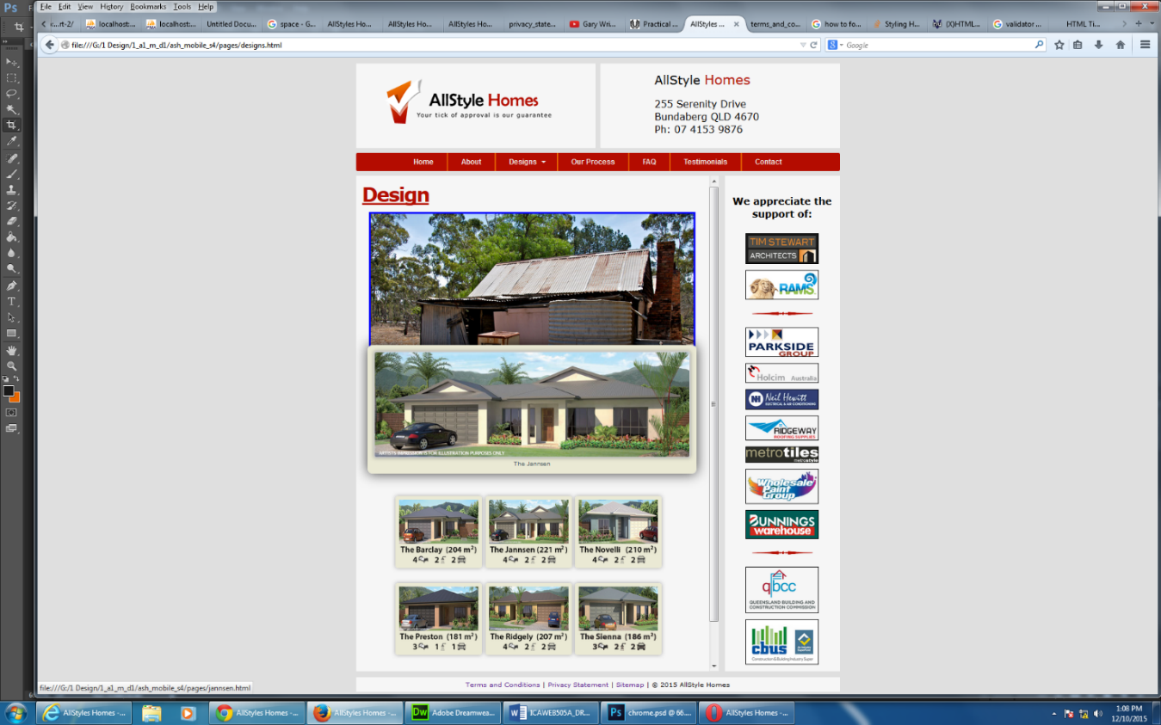

Figure : Designs page in Mozilla Firefox browser

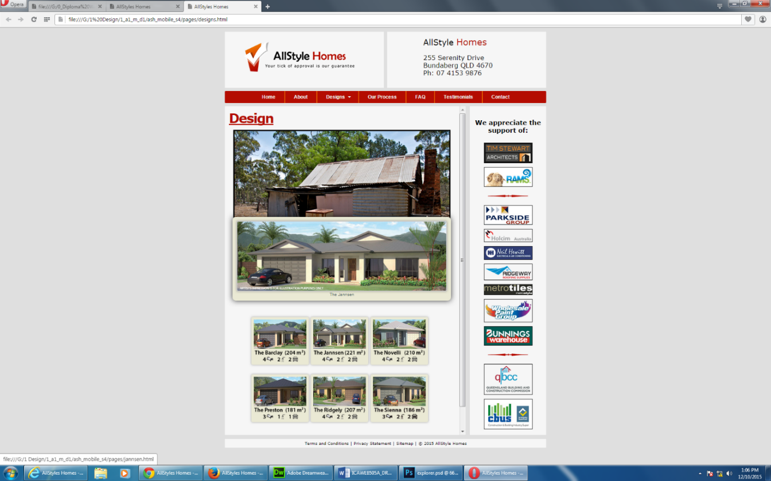

Figure : Designs page in Opera browser

1. Ensure the site meets each of the technical specification criteria

|  |  |  |  |
| --- | --- | --- | --- |
| **Element** | **Requirement** |  | **Example** |
| File naming convention | All lowercase alphanumeric up to 20 characters  Three/Four letter file type extensions  No spaces, an underscore for separation | ✓  ✓  ✓ | jannsen_sm.jpg our_process.html privacy_statement.pdf |
| Folder naming convention | Folders should be named to represent the contents of the folder eg: images  All lowercase up to 20 characters  No spaces, an underscore for separation | ✓  ✓  ✓ | complex_website  css  images  js  documents  pages |
| Browser compatibility | Internet Explorer 7+  Mozilla Firefox 10+  Google Chrome 17+ | ✓  ✓  ✓ |  |
| Browser plug-ins | No specific browser plug-ins required at this stage | ✓ |  |
| File format to be used | Image files should be .gif, .jpg or .png as appropriate  Pages should be .html | ✓  ✓ | index.html  designs.html |
| Document formats | All documents should be provided in PDF format | ✓ | privacy_statement.pdf terms_and_conditions.pdf legal_disclaimer.pdf |
| Page download times | < 10 secs at 256kbps | ✓ |  |
| Default screen resolution | 1024 x 768 pixels | ✓ |  |
| Content accessibility | W3C Content Accessibility Guidelines 2.0 (WCAG 2.0) Level A  W3C Cascading Style Sheets Level 2 Revision 1 (CSS2.1) minimum |  | http://www.w3.org/TR/WCAG/  http://www.w3.org/TR/CSS2/ |
| Target Hardware | Systems capable of running the following OS:  Windows XP and above  Apple Mac OS X | ✓  ✓ |  |

1. Ensure the site meets each of the style guide criteria

|  |  |  |  |
| --- | --- | --- | --- |
| **Element** | **Requirement** |  | **Example** |
| Fonts | All text should be in 12pt Arial font or similar. The use of bold or decorative fonts should be used only where it is required to add emphasis to the content.  Ensure that the font styles are consistent throughout the entire document. |  |  |
| Headings | Word styles should be used for all headings so as to provide a structure to the document. Headings should be used to break the document up into ideas. |  |  |
| Lists | Numbered and bulleted lists should be created using list formatting and not manually created. |  |  |
| Headers/Footers | Headers and footers should be used in all documents, unless otherwise stated, and include such things as your name, page numbers and document titles. |  |  |
| Table of Content | All report style documents should contain an automatically created table of contents that includes page numbers. |  |  |
| Margins | Page margins should be set appropriately - standard margins of 2.5cm top and bottom and 3cm left and right margins are recommended. |  |  |
| Tables | Tables should be used wherever appropriate to present information in an easy to read format. Tables should be introduced in the text to define its relationship to the content. |  |  |
| Figures, Images & Graphics | Where figures, images or other graphics are used to portray content they should be properly introduced in the text. |  |  |
| Use of Logos | The Online Systems Solutions logo should be used on all documents where appropriate to identify the origin of the document. |  |  |
| Filenames | When saving files ensure they are saved with a descriptive filename that clearly identifies the purpose of the document.  Eg: Online Systems Solutions requirements summary could be named as *OSS_reqs_summ.doc* |  |  |
| General | avoid using text boxes within documents  • avoid multi-column layouts unless specified  • all images, charts and graphs should have a description  • ensure all documents are checked for spelling, grammar and punctuation before submission  • use Word styles wherever possible as they are time saving and produce consistent results |  |  |
| Letterheads | Online Systems Solutions letterhead should be used for all official external correspondence. The letterhead has our logo on the top right hand corner with contact details directly below. The letterhead should only be used on the first page when letters are longer than one page. |  |  |
|  |  |  |  |
|  |  |  |  |
|  |  |  |  |

1. Validate your site, including your CSS against industry standards (W3C) and (submit these as screen shots)
2. Test the website to ensure it meets accessibility standards including visual impairment (submit these as screen shots)
3. Identify any issues with the site and document your rectifications
4. Re-test the site to ensure the rectifications have been properly implemented.

You should had the following to your report for this task that details the following:

* the results of your initial testing (your completed checklist will be sufficient)
* your recommendations and rectifications to issues
* the results of your testing after you have implemented your rectifications

## Project Resources

Below are a number of resources needed to complete this project. Located on the Diploma Shared Drive.

Design Brief - this document describes the requirements of the project (PDF file 499Kb)

Wireframe - full size copy of page wireframe (PDF file 138Kb)

Site Structure - full size copy of site structure and navigation (PDF file 86Kb)

Logos - zip file containing various formats of client logo (ZIP file 95Kb)

Imagemap image - source image for creating CSS imagemap (JPG file 295Kb)

## You will need to submit

The following should be included in your uploaded zip file (please ensure that there are no additional files):

* your completed website, after testing and required corrections. (Tasks 1, 2 & 3)
* your report on the implementation of CSS (Task 2)
* your testing report (Task 3)

**End of assessment**

[**https://html5.validator.nu/**](https://html5.validator.nu/)

[**https://infohound.net/tidy/**](https://infohound.net/tidy/)

[**http://quirktools.com/screenfly/#u=http%3A//localhost%3A8080/ash_mobile_s4&w=1440&h=900&a=1&s=1**](http://quirktools.com/screenfly/#u=http%3A//localhost%3A8080/ash_mobile_s4&w=1440&h=900&a=1&s=1)

**PLEASE NOTE:***The following outline begins with the assumption that you have already purchased a block of land or that you have the intention of purchasing a block in the near future. As we explain in our FAQ page, AllStyle Homes is only a building/construction company. We are not a licensed Real Estate Agency. And our business is not in the purchasing/selling of land.*

1. **The Initial Meeting:**If you already own property, it would be advantageous to bring along any or all of the following documents to this first meeting
   * the site address (street address, GPS),
   * surveyor reports,
   * elevation certificate,
   * orientation (sun rising/setting, prevailing wind/weather)
   * geology and soil testing reports,
   * land governances, and
   * council restrictions/stipulations, etc.

Note: If any or all of this information is not provided, additional research and applications may need to be undertaken before further planning can commence.

Even before the first meeting, try to have spent some time considering what you are looking for. Jot down your thoughts as to the following:

* + number of bedrooms, baths, family rooms
  + entertainment areas
  + flooring (timber, tile, vinyl, carpets
  + ceilings (flat, raked)
  + “open living” or traditional
  + sample designs, including drawings, sketches, brochures, pictures, or magazine articles you may have assembled
  + “must haves” and "wish list" for your home
  + pick some designs from our online selection

All of these aspects and more will be discussed and we consider all the options. Our goal is that by the end of the first meeting, the client will have settled on a specific design (or at least narrowed down the list). If not, a second meeting can easily be arranged.

We will review all aspects of your new home and establish your budget. We can refer you to a financing entity if you do not already have one.

1. **Preliminary Plans:**By this stage, the client should have decided if they want a custom built home ("from scratch", original floor plans) or a style from our range of existing floor plans. At this stage the final concept (from the last stage) is reviewed, and:

**If you are building a custom home:**The pricing scheme will be discussed – each house has a “Standard Design” cost with base features. The client can then add “options” at additional costs. You will then meet with the designer to start preliminary plans. A deposit for the drawing of the plans must be made. Upon our entering a contract, the deposit is deducted from the cost of your contract. During this stage we work closely with the designer to make sure your home design offers the latest in innovation & energy efficiency, fits your needs and desires, and can be built within your established budget.

**If you are building one of our floor plans:**The plans will be discussed. If you want to accept the design exactly as is there will not be any cost for the plans. If you wish to modify the design or add "options" at additional cost, then a deposite will be required for the re-drawing of the plans.

1. **Interior Design:** For clients choosing both custom homes or existing styles, we offer a range of options, within the areas of:
   * land clearing and fill dirt
   * landscaping
   * floor coverings (tiles, timber, vinyl, carpet, etc)
   * wall coverings (paint, wallpaper, etc)
   * cabinets, countertops & built-ins
   * appliances & Electrical Fixtures
   * security and technology systems
   * decorative Fixtures

“Options” allow the client to have the maximum freedom of choice while being made aware how their (additional) cost impacts on the final cost.

1. **Final Design and Pricing Phase Begins:**During this phase, your home design is refined and completed. Other activities during this phase include meetings scheduled for you to:
   * select colours & finish items with the interior designer
   * visit the cabinetmaker to select & finalize your cabinet package
   * select appliances in the appliance suppliers' showroom
   * meet with any other vendor or subcontractor requiring coordination.
2. **Final Costing:**Once your plans have been finalised, AllStyle Homes will then provide you with a quotation. The quote will outline the cost of building your dream home based on your design incorporating all of your ideas, wants and needs.
3. **Contract Execution:**At this all decisions, including colours, cabinets, appliances, and flooring should be made, your final pricing is completed, and your financing is in place.

A Building Contract will then be prepared, with a commencement date set. Upon signing of the contract the warranty insurance can be applied for. A deposit is then payable on the return of the warranty insurance. AllStyle Homes will arrange for the completion of a soil test, site survey and plans will be Energy Rated.

Working blueprints will be completed showing ‘site plan’, floor plan, external elevations, electrical layout, floor coverings, kitchen and bathroom joinery details and landscape/concrete/fencing details if required.

1. **Building Department & Governmental Agency Permitting:**Once the contract is signed and the warranty insurance received a Building permit will be applied for, to the Local Council Authority. ‘Proof of ownership’ of land is needed by way of title showing our name, rates notice or confirmation letter from conveyance/solicitor with volume and folio numbers. As well as letter of finance.
2. **Construction – Site Preparation:**This is the most exciting stage! Here, the actual building of your home takes place. Construction has begun. In the pre-foundation stage, the focus is on preparing the site and may include the removal/relocation of trees, site levelling, etc.
3. **Construction – Foundation:**All footings and underground plumbing/electrical are dug to specifications, steel reinforcement laid before the pouring of the concrete. Some clients like to be present to cast a memento into the concrete.
4. **Construction – Framing:**External and internal wall frames, roof trusses are complete. In addition, many of the mechanical, electrical, and plumbing installationsare completed. You may want to be present at the jobsite for this phase, when we schedule a jobsite meeting and together we thoroughly inspect the home prior to the wall linings being installed. Specific items we will be inspecting include not only general overall conformance to the plans and design, but specifically the plumbing, electrical, HVAC, and technology installations to allow for easy modifications you may desire before drywall is installed.
5. **Construction – Lock-Up:**External cladding or brickwork, roofing material, external doors and windows are fixed.
6. **Construction – Fixtures and fittings:**All internal cladding, architraves, skirting, doors, built in shelving and kitchen, bathroom/ensuite cabinets are fitted and fixed into position. All the finishing touches, tiling, painting, electrical and plumbing fit off are completed in accordance with the contract documents.
7. **Walk-through Inspection:** At the conclusion of construction and before you move in, we schedule a jobsite meeting and conduct a walk-through. During this meeting, we run through a checklist and inspect your entire home room by room and ensure your home is move-in ready.

You will then meet with Alex and Sheree for a full handover/inspection inspection where they will explain the house to you and ensure that everything is as per your contract specification.

At the conclusion of this inspection, we confirm your move-in date, finalize any financial transactions and completion documents, then any punch-list items generated from the walk-thru are coordinated with the subs to be completed prior to your move-in date.

1. **Handover/Move-In:**Your home is finished, all last minute items are complete, the local building department has issued the certificate of occupancy, your homeowners insurance policy is in place and the lender has made their final inspection and disbursement. Closing papers are signed and you are now ready to move in. Congratulations on your new home!
2. **First Year Warranty Inspection :**As part of our commitment to you to honour our warranty, as the first year anniversary approaches , we will organise to conduct a comprehensive (and documented) walk-through inspection. And it is truly comprehensive – from the foundations to the roof; every tile; every nail; every fitting; every fixture; front door to backdoor. If it is deemed that any defect or imperfection is a result from our construction methods we will rectify the problem at our expense.